**Fr. Conceicao Rodrigues College Of Engineering**

**Bandra,**

**Computer department,**

**SEM-V**

**Web Technology Project**

**---------------------------------------------------------------------**

**Project Topic: Forum for facilitating better connect connect between students and experts**

**Group Members:**

1. Anup Joseph(8351)
2. Shubham Pednekar(8357)
3. Shaikh Khalid(8368)

Revision History

|  |  |  |  |
| --- | --- | --- | --- |
| **Name** | **Date** | **Reason For Changes** | **Version** |
|  |  |  |  |
|  |  |  |  |

**INTRODUCTION**

The introduction of the Software Requirements Specification (SRS) provides an overview of the entire SRS with purpose, processes, functional and nonfunctional requirements, performance, Input, Output and Control. The objective of the forum is to facilitate better connect between learners and experts from the industry to provide a more holistic learning environment.

**PURPOSE**

The following document describes objectives, requirements and goals of the Student forum. It includes detailed information about the various features and working of the student forum. The targeted users of the system are student learners and subject experts. The system will be used by the students to ask questions and pose doubts about their various subjects of study. The intention of the system is to provide an environment which students can easily get their various problems cleared by professionals who actually wok on such problems.

**PROCESS**

* A student can search for questions according to related tags in the search field.
* If question is already available then the learner read the answer and if the answer is not available then he can add as a new question.
* A subject expert or another learner can answer the question if they know the reply.
* Other learners can add their own replies or upvote/downvote replies of other learners

**FUNCTIONAL REQUIREMENT**

**Registration**

* The learners as well as matter experts need to register on the forum.
* At registration the detailed information along with email, password, contact no,name of the learner are all saved.

**Ask Question**

* **Sign In:** The learner first needs to access the system using his provided email-id password. They system need to check for that username and password and then only allow him/her to access the system.
* **Add Question:**The usercan add question by pressing the Add Question button.The user also needs to provide tags about the question to improve the visibility of the question to the subject experts and other learners.

**Search Question:**

* The learner can search for the question according to the tags related to the question.
* The tags of the question also help in adding visibility of the question to the learner.

**Answer Questions:**

* The subject professionals can search for the questions according to the tags specified for the question.
* After searching for the provided question the expert/learner can answer the question in the reply page
* Also the learner/expert can upvote/downvote the question and replies in the answer page.

**Database:**

* **User related Information:** Each user shall have the following mandatory information first name, last name, phone number, address, email address, username and Password.
* **Question related Information:**Each question has the following information associated with it:

Replies to each questions

Upvote, downvote information of each questions

Name of each learner who has replied to the question.

**NON FUNCTIONAL REQUIREMENTS**

**Safety and Security Requirements**

* **Passenger Identification:** The system requires the user to identify himself/herself using password

**Login ID:** Any user who uses the system shall have a Login ID and Password.

* **Modification:**The questions added to the database can be done only by the database administrator

.

**Software Quality Attributes**

**Maintainability:**

* **Back Up:** The system shall provide the capability to back-up the data
* **Errors**: The system shall keep a log of all the errors.
* **Reliability:** Availability The system shall be available all the time

**PERFORMANCE**

* **Response Time:** The system gives dynamic responses to the system as the search field is set
* **Capacity:** The architecture of the Nodejs v8 engine is such that it can supprot 1000 requests per minute.
* **User-interface:** The user-interface screen shall respond within 4 seconds.
* **Network Connection**: They should be connected to internet 24 X 7. And the server must be on all time.

**TECHNLOGY STACK**

* **NodeJs:** Node.js is an open-source, cross-platform, JavaScript runtime environment that executes JavaScript code outside of a browser.
* **BootStrap:** Bootstrap is a free and open-source CSS framework directed at responsive, mobile-first front-end web development. It contains CSS- and JavaScript-based design templates for typography, forms, buttons, navigation and other interface components.
* **jQuery:** jQuery is a JavaScript library designed to simplify HTML DOM tree traversal and manipulation, as well as event handling, CSS animation, and Ajax.
* **ExpressJs:** Express is a minimal and flexible Node.js web application framework that provides a robust set of features for web and mobile applications.
* **SQLite3:** SQLite is a relational database management system (RDBMS) contained in a C library. In contrast to many other database management systems.
* **Ajax:** Ajax is a set of web development techniques using many web technologies on the client side to create asynchronous web applications.

**INPUT**

* The user can enter the questions and tag according to the subject of the question
* The user can enter the tags of the question and search for the question according to the tags
* A subject expert can enter answer to the question and mark upvotes and downvotes to the question

**OUTPUT**

* A user of the system be it subject expert or the learner of the system can view the answer to the system.
* The user of the system can view all the tags related to a question
* He can search the question according to the tags of the question and can view the question as a modal.

**APPLICATION USER INTERFACE:**

Login Form

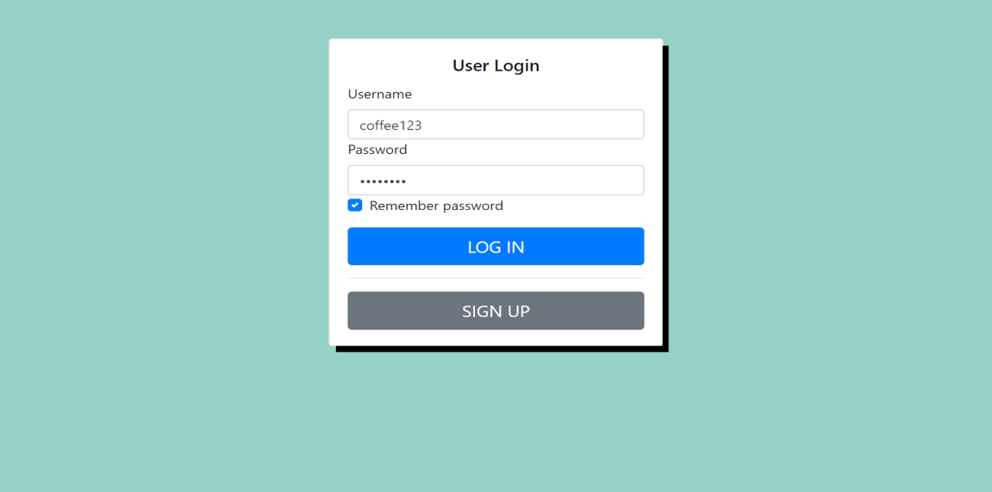

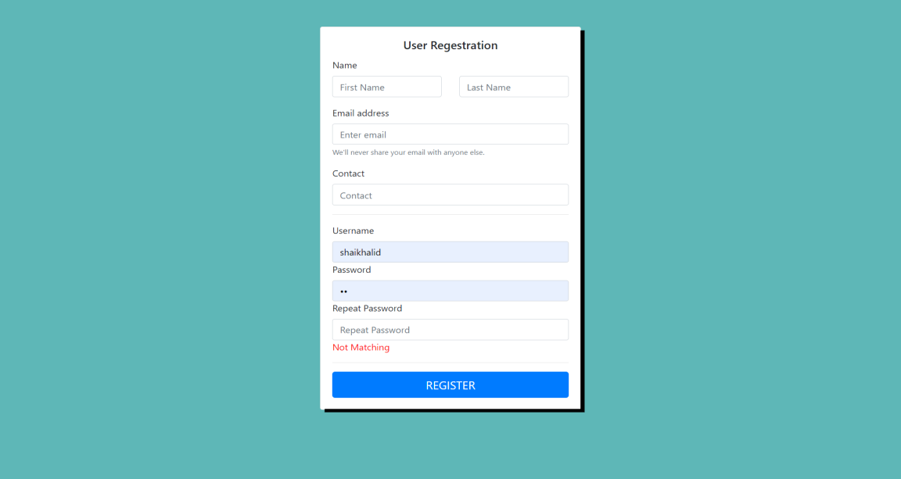

Home Page

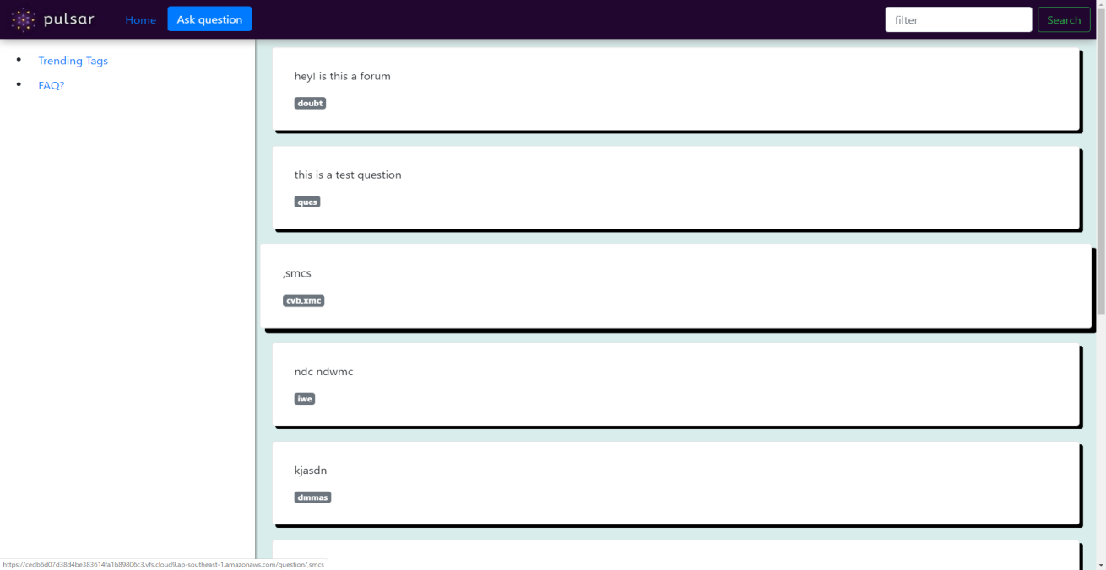

Ask Question modal

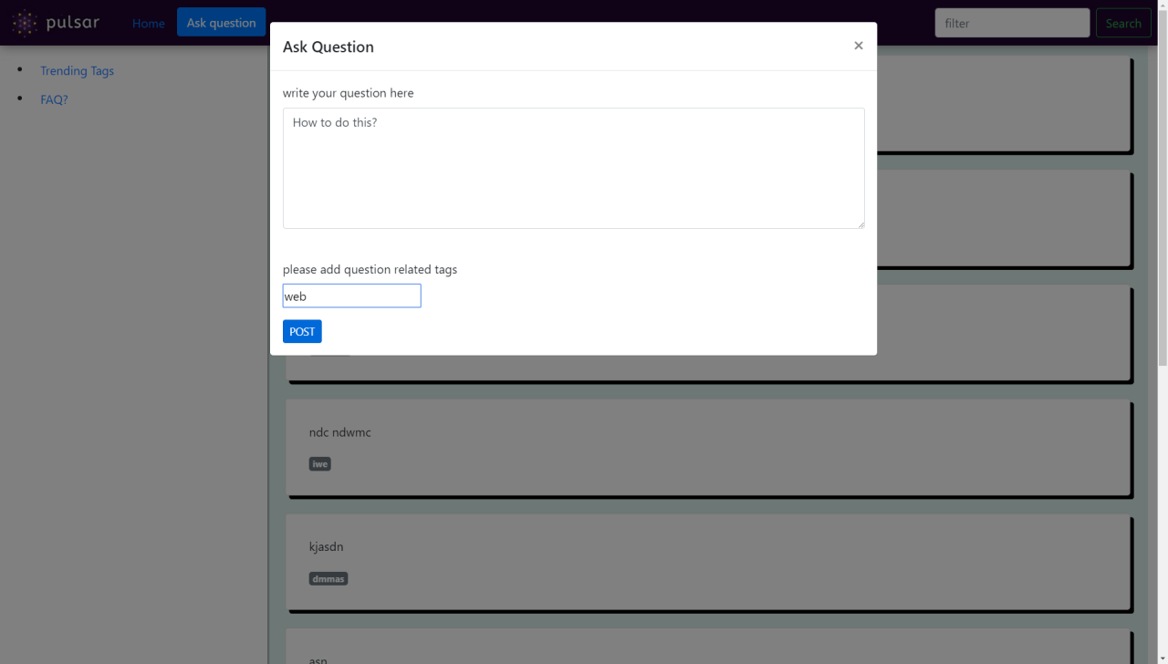

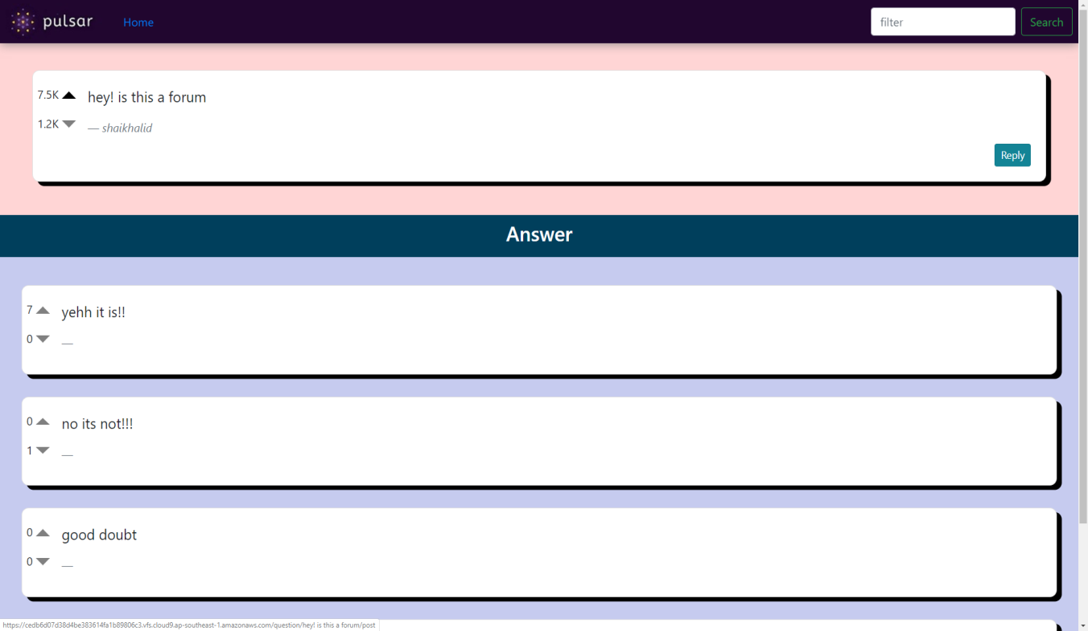

Search facility

